POPIS TUN TAP

Vysvetlivky:
Modre - překlad
Cervene - nejasnosti
Zelene -poznamky

(Chci si ujasnit o kterem bloku z toho schematu se mluvi….)

VAS MODEL OpenVPN

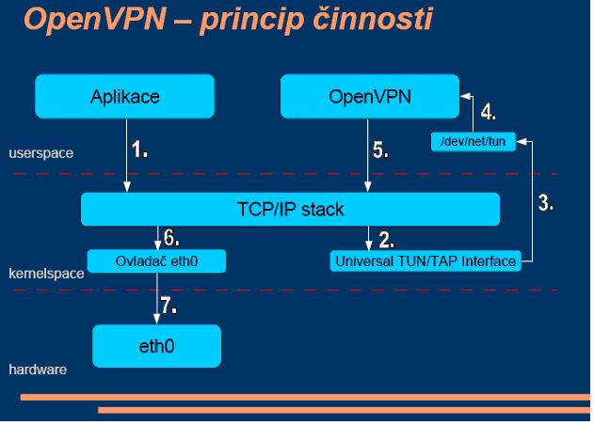

MUJ MODEL funkce virtuálního sítového rozhrani TUN a TAP
(Rozdil oproti OpenVPN je ten ze nesifruje a proto ten blok(OpenVPN) tu neni)
(je to jen muj navrh).
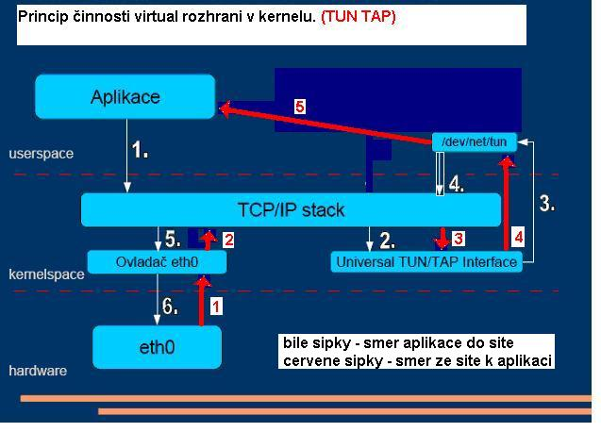
SMER Z APLIKACE DO SITE
------------------------
1) "Aplikace" posle data do "TCP/IP stacku"

2) Data se poslou z "TCP/IP stacku" na "Universal TUN/TAP interface" (pod "Universal TUN/TAP interface" si mam predstavit nejaky program ktery vytvari to
virtualni rozhrani?)

3) Z "Universal TUN/TAP interface" se odeslou na "/dev/net/TUN" (co si mam predstavit pod "/dev/net/TUN"? nejaky buffer pres ktery si ta data predavaji?
?misto TUN tam byt i TAP ne?)

4) Pak by podle meho mela byt poslana znova do "TCP stacku"

5) ...Pak na eth0 "ovladac"
6) ...a z neho na "sitovku"

SMER ZE SITE K APLIKACI
-----------------------

1) Data ze site jdou na na eth0 "ovladac"

2) z eth0 "ovladace" na "TCP/IP stack"

3) Z "TCP/IP stacku" na "Universal TUN/TAP interface"

4) z"Universal TUN/TAP interface" do "/dev/net/TUN"

5) z "/dev/net/TUN" do aplikace

Universal TUN/TAP device driver.

- Description

------------------------------------------------------------------------------
TUN/TAP provides packet reception and transmission for user space programs.
TUN a TAP poskytuji prijem a vysilani paketu pro programy bezicich v USER SPACE.

--------------------------------------------------------------------------
It can be viewed as a simple Point-to-Point or Ethernet device, which
instead of receiving packets from a physical media, receives them from
user space program and instead of sending packets via physical media
writes them to the user space program.

To(blok „/dev/net/TUN_TAP“?) muze byt videno(„aplikacemi“) jako Point to Point nebo Ethernet zarizeni, ktere misto prijimani paketu z fyzickeho media prijima z user space programu(no a taky muze z „Universal TUN/TAP interface“ ne?!) a misto zapisu na fyzicke medium zapisuje do user space programu(opet muze zapisovat do „Universal TUN/TAP interface“?!).
Poznamka:To vse za predpokladu ze It can be viewed as a simple Point-to-Point or Ethernet device = blok „/dev/net/TUN_TAP“.
---------------------------------------------------------------------------

------------------------------------------------------------------------------
When a program opens /dev/net/tun, driver creates and registers corresponding
net device tunX or tapX. After a program closed above devices, driver will
automatically delete tunXX or tapXX device and all routes corresponding to it.

Kdyz program(nechapu… jako nejaka „user space aplikace“? ) otevre(jak otevre? co si pod tim mam představit?, pokud je/dev/net/tun jen nejaky buffer tak chapu) /dev/net/tun, ovladac(ovladac je blok "Universal TUN/TAP interface") vytvori a registruje odpovidajici sitove zarizeni TUNx nebo TAPx(pod TUNx nebo TAPx tim si mam představit jaky blok?). Po tom co program (blok „aplikace“ ?)zavre vyse zminene zarizeni (myslen blok „/dev/net/tun“?)ovladac automaticky smaze tunXX or tapXX (co teda smaze?) a zavre všechny routy tomu odpovidajici.

----------------------------------------------------------------------------

Universal TUN/TAP device driver Frequently Asked Question.

1. What is the TUN ?
The TUN is Virtual Point-to-Point network device.
TUN driver was designed as low level kernel support for
IP tunneling. It provides to userland application
two interfaces:
- /dev/tunX - character device;
- tunX - virtual Point-to-Point interface.

Userland application can write IP frame to /dev/tunX
and kernel will receive this frame from tunX interface.
In the same time every frame that kernel writes to tunX
interface can be read by userland application from /dev/tunX
device.

2. What is the TAP ?
The TAP is a Virtual Ethernet network device.
TAP driver was designed as low level kernel support for
Ethernet tunneling. It provides to userland application
two interfaces:
- /dev/tapX - character device;
- tapX - virtual Ethernet interface.

Userland application can write Ethernet frame to /dev/tapX
and kernel will receive this frame from tapX interface.
In the same time every frame that kernel writes to tapX
interface can be read by userland application from /dev/tapX
device.

3. What platforms are supported by TUN/TAP driver ?
Currently driver has been written for 3 Unices:
Linux kernels 2.2.x, 2.4.x
FreeBSD 3.x, 4.x, 5.x
Solaris 2.6, 7.0, 8.0

4. What is TUN/TAP driver used for?
As mentioned above, main purpose of TUN/TAP driver is tunneling.
It is used by VTun (http://vtun.sourceforge.net).

5. How does Virtual network device actually work ?
Virtual network device can be viewed as a simple Point-to-Point or
Ethernet device, which instead of receiving packets from a physical
media, receives them from user space program and instead of sending
packets via physical media sends them to the user space program.

Let's say that you configured IPX on the tap0, then whenever
kernel sends any IPX packet to tap0, it is passed to the application
(VTun for example). Application encrypts, compresses and sends it to
the other side over TCP or UDP. Application on other side decompress
and decrypts them and write packet to the TAP device, kernel handles
the packet like it came from real physical device.

Kdykoliv jadro posle nejake pakety do TUN jsou v tu chvili dostupne pro aplikaci a naopak

6. What is the difference between TUN driver and TAP driver?
TUN works with IP frames. TAP works with Ethernet frames.

7. What is the difference between BPF and TUN/TAP driver?
BFP is a advanced packet filter. It can be attached to existing
network interface. It does not provide virtual network interface.
TUN/TAP driver does provide virtual network interface and it is possible
to attach BPF to this interface.

8. Does TAP driver support kernel Ethernet bridging?
Yes. Linux and FreeBSD drivers support Ethernet bridging.

----
TUN
----
TUN je virtualni Point to Point sitove zarizeni. Ovladac TUN byl navrzen jako nizko urovnova podpora do jadra pro IP tunelovani. To poskytuje aplikacim bezicim v userspace dve rozhrani:
1) /dev/TUNx znakove zarizeni
2) TUNx virtualni Point to Point rozhrani

Aplikace bezici v userspace muzou zapisovat pakety do /dev/TUPxa jadro je prijima z TUNx rozhrani. Zaroven kazdy paket, ketry jadro zapise do TUNx muze byt precten aplikaci z /dev/TUNx.
-------------------------------------------------------------------------------------------------------------------------------------------------------------

----
TAP
----
TAP je virtualni Ethernet sitove zarizeni. TAP ovladac byl navrzen jako nizko urovnova podpora do jadra pro Ethernet tunelovani.To poskytuje aplikacim bezicim v userspace dve rozhrani:
1) /dev/TAPx znakove zarizeni
2) TAPx virtualni Ethernet rozhrani

Aplikace bezici v userspace muzou zapisovat pakety do /dev/TAPx a jadro je prijima z TAPx rozhrani. Zaroven kazdy paket, ketry jadro zapise do TAPx muze byt precten aplikaci z /dev/TAPx.

V soucasnosti jsou ovladace techto virtualnich adapteru napsany pro Linuxove jadra 2.2.x 2.4.x, FreeBSD 3.x, 4.x, 5.x a Solaris 2.6 ,7.0, 8.0.
--------------------------------------------------------------------------------------------------------------------------------------------------------

------------------------------
Rozdil mezi TUN a TAP adaptery
------------------------------
TUN pracuje s pakety tzn. na 3. vrstve (sitove) modelu ISO/OSI kdezto TAP pracuje s Ethernet ramci tzn. na druhe (spojove) vrstve.

